Czechoslovak History in Short

During World War I, in 1916, together with Edvard Beneš and Milan Rastislav Štefánik (a Slovak astronomer and war hero), Tomáš Garrigue Masaryk created the Czechoslovak National Council. Masaryk in the United States, Štefánik in France, and Beneš in France and Britain worked tirelessly to gain Allied recognition. When secret talks between the Allies and Austrian emperor Charles I (1916-18) collapsed, the Allies recognized, in the summer of 1918, the Czechoslovak National Council would be the main contributor to the future Czechoslovak government.

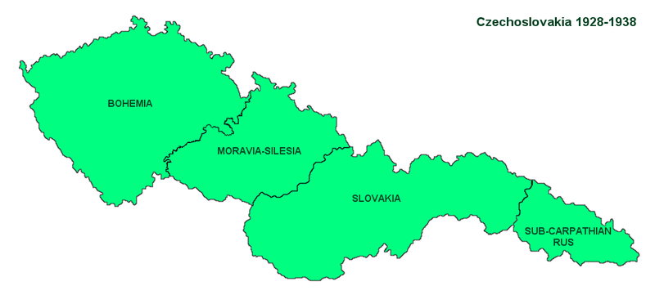

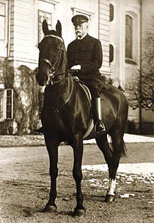
The independence of Czechoslovakia was officially proclaimed in Prague on October 28, 1918 in Smetana Hall of the Municipal House. The Slovaks officially joined the state two days later in the town of Martin. The new nation had a population of over 13.5 million. It had inherited 70 to 80% of all the industry of the Austro-Hungarian Empire. Czechoslovakia was one of the world's ten most industrialized countries.
Milan Rastislav Štefánik
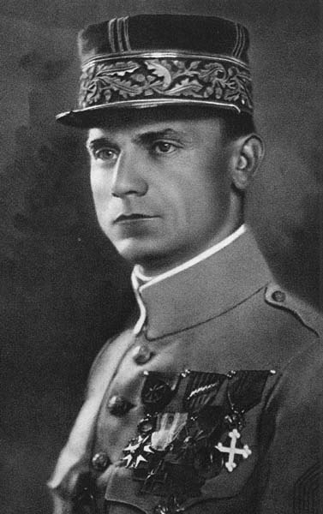

Tomáš Garrigue Masaryk
the first Czechoslovak prezident

Although Czechoslovakia was the only central European country to remain a parliamentary democracy from 1918 to 1938, it faced problems with ethnic minorities, the most important of which concerned the country's large German population. The Sudeten Germans constituted 3 to 3.5 million out of 14 million of the interwar state's population and were largely concentrated in the Bohemian and Moravian border regions, called the Sudetenland in German. Some members of this minority, which were predominantly sympathetic to Germany, undermined the new Czechoslovak state.

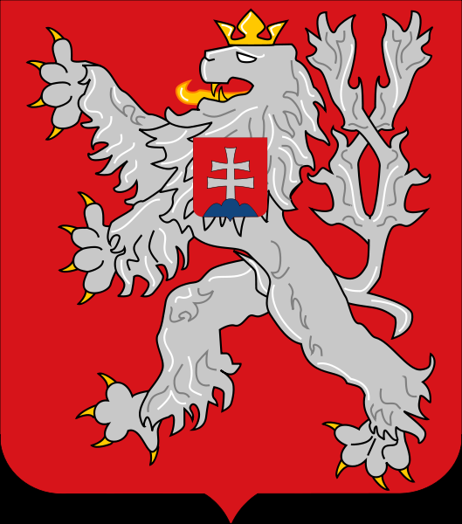
Hitler's rise in Germany, the German annexation (Anschluss) of Austria, the resulting revival of revisionism in Hungary and of agitation for autonomy in Slovakia, and the appeasement policy of the Western powers (France and the United Kingdom) left Czechoslovakia without allies, exposed to hostile Germany and Hungary on three sides and to unsympathetic Poland on the north.

Coat of Arms of
Czechoslovakia – small

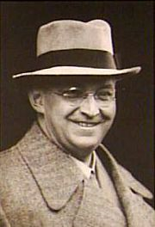
Konrad Henlein
After the Austrian Anschluss, Czechoslovakia was to become Hitler's next target. The German nationalist minority, led by Konrad Henlein and vehemently backed by Hitler, demanded the union of the predominantly German districts with Germany. Threatening war, Hitler extorted through the Munich Agreement in September 1938 the cession of the Bohemian, Moravian and Czech-Silesian borderlands - Sudetenland where all Czech population were forcibly expelled. On September 29, 1938, the Munich Agreement was signed by Germany, Italy, France, and Britain. The Czechoslovak government agreed to abide by the agreement. The Munich Agreement stipulated that Czechoslovakia must cede Sudetenland territory to Germany. Beneš resigned as president of the Czechoslovak Republic on October 5, 1938, fled to London and was succeeded by Emil Hácha.
The Munich Agreement
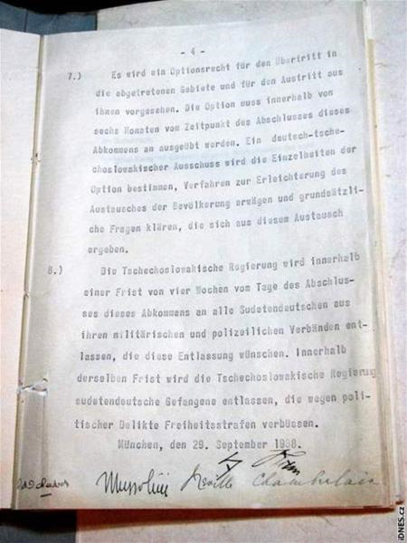

On March 14, 1939 Slovaks declared independence as a satellite state under Jozef Tiso. Hitler forced Hácha to surrender what remained of Bohemia and Moravia to German control on 15 March 1939, establishing the German protectorate "Bohemia and Moravia", which was created on March 16th.

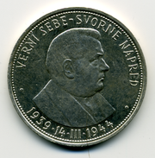
50 Slovak koruna silver coin
on the occasion of 5 years anniversary
of Slovak Republic (1939–1945) with
an effigy of the slovak president Josef Tiso.

Edvard Beneš and other Czechoslovak exiles in London organized a Czechoslovak Government-in-Exile and negotiated to obtain international recognition for the government and a renunciation of the Munich Agreement and its consequences. The government was recognized by government of United Kingdom Foreign Secretary Lord Halifax on July 18, 1940. In July and December 1941, the Soviet Union and United States also recognized the exiled government, respectively.
Edvard Beneš
2nd president of Czechoslovakia
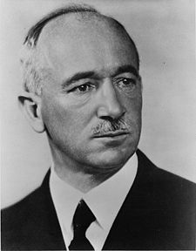

From September 21, 1944, Czechoslovakia was liberated by Soviet troops (the Red Army), supported by Czech and Slovak resistance, from the east to the west, only southwestern Bohemia was liberated by other Allied troops from the west.

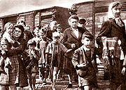
The Potsdam Agreement provided for the expulsion of Sudeten Germans to Germany under the supervision of the Allied Control Council. Decisions regarding the Hungarian minority reverted to the Czechoslovak government. In February 1946, the Hungarian government agreed that Czechoslovakia could expatriate as many Hungarians as there were Slovaks in Hungary wishing to return to Czechoslovakia.

Transport of the evacuated Czech Germans after Second World War

Government of the Czechoslovak Republik ,installed at Košice on April 4 and moved to Prague in May, was a National Front coalition in which three socialist parties—Communistic Party, Czechoslovak Social democratic Party, and Czechoslovak National Socialist Party—predominated. Certain nonsocialist parties were included in the coalition; among them were the Catholic People's Party (in Moravia) and the Democratic Party (Slovakia).

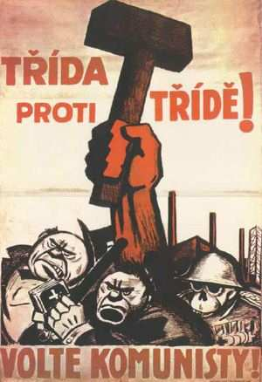

In the May 1946 election, the Communistic Party won in the Czech part of the country (40.17%), and the anti-Communist Democratic Party won in Slovakia (62%). In sum, however, the Communistic Party won a plurality of 38 percent of the vote at countrywide level. Edvard Beneš continued as president of the republic. The Communist leader Klement Gottwald became prime minister. Most important, although the communists held only a minority of portfolios, they were able to gain control over all key ministries (Ministry of the Interior etc. ).

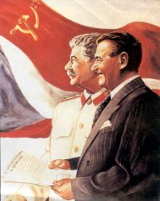

On February 20, 1948, the twelve noncommunist ministers resigned, in part, to induce Beneš to call for early elections: Beneš refused to accept the cabinet resignations and did not call for elections. In the meantime, the Communistic Party garnered its forces for the coup d'état of 1948. The communist-controlled Ministry of Interior deployed police regiments to sensitive areas and equipped a workers' militia. On February 25, Beneš, perhaps fearing Soviet intervention, capitulated. He accepted the resignations of the dissident ministers and received a new cabinet list from Gottwald, thus completing, under the cover of superficial legality, the communist takeover.

Klement Gottwald and Stalin on the leaflet

Destalinization had a late start in Czechoslovakia. In the early 1960s, the Czechoslovak economy became severely stagnate. The industrial growth rate was the lowest in Eastern Europe. As a result, in 1965, the party approved the New Economic Model, introducing free market elements into the economy. The Communistic Party "Theses" of December 1965 presented the party response to the call for political reform. Democratic centralism was redefined, placing a stronger emphasis on democracy. The leading role of the Communistic Party was reaffirmed but limited. Slovaks pressed for federalization. On January 5, 1968, the Communistic Party Central Committee elected Alexander Dubček, a Slovak reformer, to replace Novotný as first secretary of the Communistic Party. On March 22, 1968, Novotný resigned from the presidency and was succeeded by General Ludvík Svoboda.

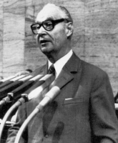
Dubček carried the reform movement a step further in the direction of liberalism. After Novotný's fall, censorship was lifted. The press, radio, and television were mobilized for reformist propaganda purposes. The movement to democratize socialism in Czechoslovakia, formerly confined largely to the party intelligentsia, acquired a new, popular dynamism in the spring of 1968 (the "Prague Spring").

Alexandr Dubček

A program adopted in April 1968 set guidelines for a modern, humanistic socialist democracy that would guarantee, among other things, freedom of religion, press, assembly, speech, and travel; a program that, in Dubček's words, would give socialism "a human face."
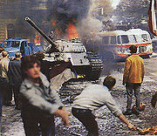
The internal reforms and foreign policy statements of the Dubček leadership created great concern among some other Warsaw Pact governments. Communistic Party conservatives had misinformed Moscow regarding the strength of the reform movement. As a result, the troops of Warsaw Pact countries (except Romania) invaded Czechoslovakia during the night of August 20-21, 1968. Opposition to the invasion was expressed in numerous spontaneous acts of nonviolent resistance. On January 19, 1969, student Jan Palach set himself on fire in Prague's Wenceslas Square to protest against the renewed suppression of free speech. Prague, 1968

Protest banner in Russian reading
"For your freedom and ours"
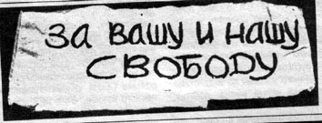
Dubcek remained in office only until April 1969. Gustáv Husák (a centrist, and interestingly one of the Slovak "bourgeois nationalists" imprisoned by his own Communistic Party in the 1950s) was named first secretary (title changed to general secretary in 1971). A program of "Normalization"—the restoration of continuity with the prereform period—was initiated. Normalization entailed thoroughgoing political repression and the return to ideological conformity. A new purge cleansed the Czechoslovak leadership of all reformist elements. In 1975, Gustáv Husák added the position of president to his post as party chief.

Gustáv Husák
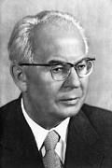
The most prominent opposition to the process of normalization was the movement known as Charter 77. The movement took its name from the title of a document initially circulated within Czechoslovakia in January 1977. Originally appearing as a manifesto in a West German newspaper and signed by 243 Czechoslovak citizens representing various occupations, political viewpoints, and religions, the document by the mid-1980s had been signed by 1,200 people.

The first anti-Communist demonstration took place on March 25, 1988 in Bratislava (the Candle demonstration in Bratislava). It was an unauthorized peaceful gathering of some 2,000 (other sources 10,000) Roman Catholics. Demonstrations also occurred on August 21, 1988 (the anniversary of the Soviet intervention in 1968) in Prague, on October 28, 1988 (establishment of Czechoslovakia in 1918) in Prague, Bratislava and some other towns, in January 1989 (death of Jan Palach on January 16, 1969), on August 21 1989 and on October 28 1989.

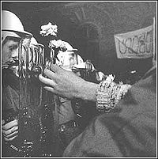
On 17 November 1989, the communist police violently broke up a peaceful pro-democracy demonstration, brutally beating many student participants. In the days which followed, Charter 77 and other groups united to become the Civic Forum, an umbrella group championing bureaucratic reform and civil liberties. Its leader was the dissident playwright Václav Havel. Intentionally eschewing the label "party", a word given a negative connotation during the previous regime, Civic Forum quickly gained the support of millions of Czechs, as did its Slovak counterpart, Public Against Violence.

Non-violent protesters face armed policemen

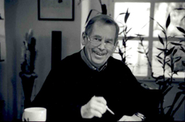
Faced with an overwhelming popular repudiation, the Communist Party all but collapsed. Its leaders, Husák and party chief Miloš Jakeš, resigned in December 1989, and Havel was elected President of Czechoslovakia on 29 December.

On 1 January 1993, the Czech Republic and the Republic of Slovakia were simultaneously and peacefully founded.

Václav Havel

