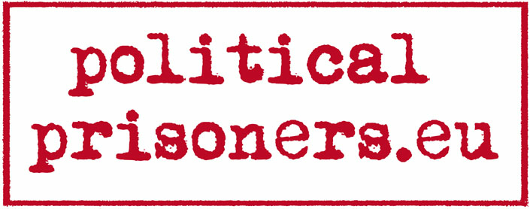
International Workshop
“Life in Czechoslovak Communist Labour Camps”
1-3 May 2009

Friday  1st May 2009 | Saturday  2nd May 2009 | Sunday  3rd May 2009
Arrival of participants | 8:00  Breakfast  9:00 – 10:30  Trip from Prague to Příbram | 09.00  Breakfast
14:00  Registration in the hostel | 10:30 – 13:30  The Vojna Memorial near the town of Příbram  “Everyday life in a Stalinist labour camp: meeting the survivors” | 10:00 – 13:00  Workshop session  “Investigating the meaning of “Victims of Stalinism”
15.00  Official Opening  Introduction of the Project, Team and Programme  Presentation of the website  www.politicalprisoners.eu | 13:30 – 14:15 Lunch | 14.00  Departures  &  Good bye
 | 14:15 – 15:00  Meeting a political prisoner  Augustin Bubník | 14.00  Departures  &  Good bye
 | 15:00 – 16:30  Movie | 14.00  Departures  &  Good bye
16:00  Meeting a political prisoner  Břetislav Jeník | 16:30  Transfer to Prague | 14.00  Departures  &  Good bye
17.30 Welcome Dinner | 18:00 Dinner | 14.00  Departures  &  Good bye
19:00-21:00  Prague and the Communist Past  (night - city guided tour) | 19: 30  Workshop session  „Meaning of mass persecussion in Europe“ | 14.00  Departures  &  Good bye
21.00  Ice-breaking Evening |  | 14.00  Departures  &  Good bye

