The Main Personalities in the Czechoslovak History
in Years 1945-1960

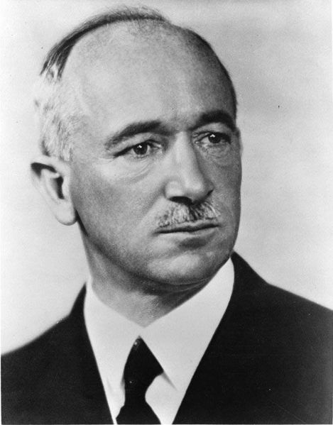
Edward Beneš was the second President after T.G. Masaryk from 1935 to 1938. He was also a President in exile in 1940– 1945 and the President of Czechoslovakia after the War (1945–1948). Together with T.G. Masaryk and M. R. Štefánik, he took part in the resistance movement during WWI and he is one of the founders of Czechoslovakia.

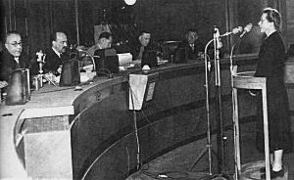
JUDr. Milada Horáková was a Czech politician. During WWII she was arrested and brutally interrogated by Gestapo. She was sentenced to death and then this was changed to life imprisonment. The rest of the war she spent in the concentration camp in Terezín. After the war she joined the National Socialist party. In 1949 she was arrested, sentenced in the communist political processes to death. She was fully rehabilitated in 1968.

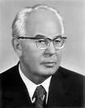
Gustav Husák (1913–1991) – Czechoslovakian Communist politician and President of The Czechoslovakian Socialisti Republic from 1975–1989. In 1950 he was accused together with V. Clementis, L. Novomeský, and many others for so-called bourgeois nationalism. In February 1951 he was locked up and in 1954 sentenced for life imprisonment. He was one of the minority who did not confess any blame. That probably saved his life. In 1960 he was pardoned by President A. Novotný and in 1963 he was fully rehabilitated. In 1969 he was a leader of the Communist party – by May 1971 he was the General Secretary of the party. In 1975 he became a President of the Czechoslovak Socialistic republic.

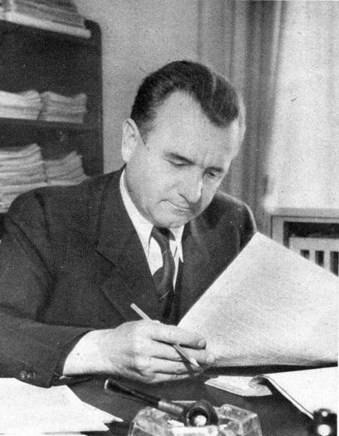
Klement Gottwald (1896-1953) was a Czechoslovakian Communist politician, longtime leader of the Communist Party of Czechoslovakia, prime minister and president of Czechoslovakia. In May 1946 Klement Gottwald, leader of the communist party, managed to win the elections with an astonishing success: 38% of the votes. This has been the widest electoral success of the communist party ever recorded in a free election.

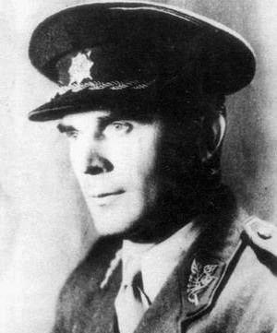
General Heliodor Píka (1887–1949) was a Czechoslovakian soldier and legionnaire. During WWII he formed an army unit out of Czechoslovakian soldiers in Soviet camps. In May 1945 he returned to Prague where he was named the Deputy of the Chief of General Staff of Czechoslovakian Army. After February 1948 he was arrested and executed. In 1968 his
process was renewed and fully rehabilitated.

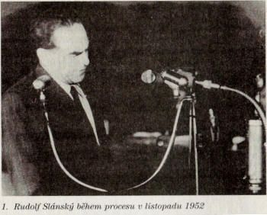
Rudolf Slánský (1901 – 1952) – Czech communist politician, member of the Central Commitee of the Communist Party of Czechoslovakia and General Secretary of the party (1945 – 1951).

Process with Rudolf Slánský – Political processes launched against all sections of society, which did not miss even the main representatives of the Communist Party. From 1950 the State secret police concentrated on “searching the enemy even among its own.“ The leading communist investigated was Secretary-General of the Communist Party Rudolf Slánský.

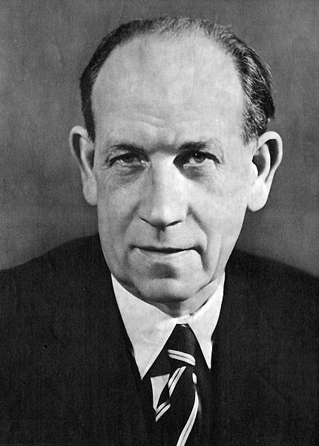
Antonín Zápotocký (1884 – 1957) was communist Prime Minister of Czechoslovakia from 1948 to 1953 and President of Czechoslovakia from 1953 to 1957. Zápotocký became Prime Minister on 15 June 1948, replacing Klement Gottwald, who became President. On 14 March 1953, shortly after his return from Stalin's funeral, Gottwald died, and was succeeded as President by his Prime Minister. Zápotocký stayed in office till his death in Prague in 1957.

