The Main Terms from Czechoslovak Communistic History

A pardon from the President Antonín Zápotocký on May 9, 1960. It was announced on the 15th anniversary of the end of WW2. This pardoned the sentences for seditious crime. It was the biggest amnesty from 1946 until the fall of communism in 1989.

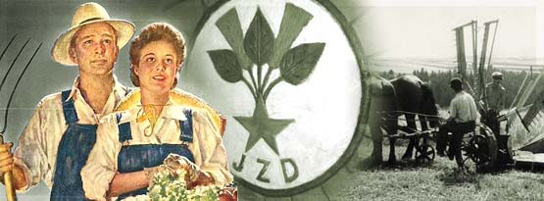
Collectivization took place in Czechoslovakia during the 1950’s. As a result the major part of agricultural land was centered into JZD – Unified Cooperative Farms. This process was not without violence and threats.

Counter Intelligence Corps (CIC) was an American intelligence service established during WWII in December 1943. Its task was to search for and eliminate German agents in the ranks of allied armies. After WWII its activities were focused on the Soviet Bloc, and especially in the 50’s it recruited and trained agents who were employed to work within the region
during two years, starting in April 1950. Eleven people were sentenced to death and executed, including J. Vávra- Stařík, Josef Matouš, and Rudolf Lenhard.

KPV – The Confederation of Political Prisoners of the Czech Republic – the association of political prisoners from formel Czechoslovakia. It was established January 3, 1990.
of Soviet influence including Czechoslovakia.

“Mukl” – someone who was in prison, the word “mukl” itself comes from the abbreviation of – “a man on death row” (in Czech: muž určený k likvidaci). It was a label given to political prisoners imprisoned by communist or Nazi regimes that were not supposed to be released and were supposed to die in prisons or concentration camps. Later on, this label started

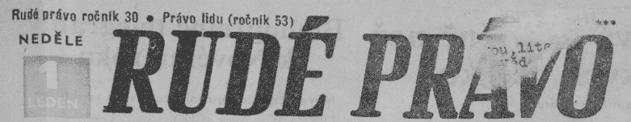
Rudé právo – (in English “Red right”) up until 1989, a daily newspaper of the Communist Party.

Scouts is an international movement whose aim is education and self-education of children. During Czech history, Scouts was prohibited three times by a regime (by the Nazis and Communists) because it always stood up actively against totalitarianism. Many scout representatives died during the rebellious activity, were executed, or imprisoned in Nazi concentration camps. Many of them were victims in political processes in the 50’s. Scouting always did its best with political freedom (in 1945, 1968, and 1989) and immediately renewed its activity.

State secret police known under the abbreviation StB, was a political police force in Czechoslovakia during the communist era.

Světlana – a resistance group in Czechoslovakia, which was founded by a former partisan chief Josef Vávra-Stařík. It was founded in 1948 in the city of Zlín that was at that time re-named to Gottwaldov as a tribute to the fi rst working vlase President Gottwald. The group was named after the daughter of Vávra-Stařík “Světlana.” There were three men who were the main leaders: Apart from Vávra-Stařík, there was Josef Matouš and Rudolf Lenhard. From March 1949 until May 1950, StB arrested 400 citizens at the border of the Moravian and Silesian region and also in South and Central Moravia. The prosecutors, together with StB officers, put the members of Světlana into 16 groups, which were sentenced in 16 trials.

The law 231/48 Sb. according to which most of the political prisoners in Czechoslovakia were sentenced in a massive way. On the basis of these decrees were 21 342 persons arrested and 713 persons sentenced to death.

Vindictive decrees – are part of the decrees of the president Edvard Beneš, which was passed after Second World War (they are well – known as a Beneš´s decrees as well). These decrees (particularly big retribution decree - number of the decree 16/1945 Sb. from 19th June 1945 and small retribution decree – number of decree 138/1945 Sb. from 27th October 1945) were instrumental for punishment of the Nazi criminals and collaborators.

Vindictive prisoners – prisoners sentenced on a basis of “vindictive decrees” for cooperation and collaboration with Nazi Germany. A state prisoner was also called a political prisoner, then there was a category of criminal prisoners.

Warsaw brigades – Warsaw Agreement was an army pact of the European countries of the Eastern bloc, which existed in 1955 – 1991. It was based on the Agreement of friendship, cooperation and help, which was signed on May 14, 1955 by representatives of Albania, Bulgaria, Czechoslovakia, Hungary, Germany, Poland, Romania, and U.S.S.R. in Warsaw.

